Meeting House Hill Cemetery, Centerville, Barnstable County, Massachusetts

HALLETT
Eunice M., d. 6 Aug. 1890, ae. 67 yrs., 1 mo.
George O., d. 2 Aug. 1868, ae. 18 yrs., 4 mos., 17 days. Son of Moses F. & Eunice M. Hallett.
Moses F., d. 7 Jan. 1892, ae. 74 yrs., 5 mos.

Phinney's Lane Cemetery, Centerville, Barnstable County, Massachusetts
HALLETT
William, d. 26 Aug. 1802, ae. 5 yrs., 10 mos., 26 days. Son of Mr. William & Mrs. Jemima Hallett.

Sandwich Tobey Cemetery

Thomas Hallet 1815
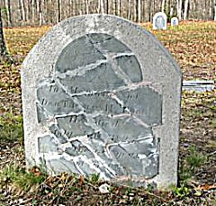
In Memory of
Mr. THOMAS HALLET
who died
Dec. 15th, 1815
Aged 87 years.

Desire Hallet 1824
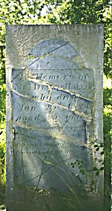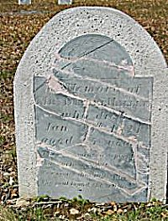
In Memory of
Mrs DESIRE HALLET
who died
Jan 20th 1824
Aged 35 years
The left photo supplied by Timothy Tobey August 2002 shows the restored stone. The right photo supplied by Kevin Murphy May 2006 shows the stone after additional restoration work.

Elizabeth Hallet 18__
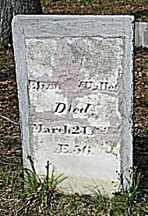
Elizabeth Hallet
Died
March 24, 18__
AE. 56
Falmouth Davisville Cemetery
up to 1870Special note - for a complete survey of this cemetery including photographs
visit the Falmouth Genealogical Society web site at www.falgen.org)
 | Azuba Baker  (wife of Barnabas) |  | 1843 - May 3 |  | adult
Possible azuba hallett

Barnstable - Centerville Beechwood Cemetery
(aka Oak Grove Cemetery)
up to 1860
Harvey Hallett |  | 1841 |  | 44

Barnstable Cummaquid Cemetery
(aka East Barnstable Cemetery)
(aka Dimmock's Lane Cemetery)
up to 1860
Joseph H Hallett  (son of Nathaniel S & Mary D) |  | 1854 - January 5 |  | 19

Betsey Hallett  (wife of Reuben) |  | 1855 - December 5 |  | 38

Mary E Hallett  (dau of Charles G & Elvira) |  | 1857 - December 8 |  | 4

Betsey G Hallett |  | 1861 - November 13 |  | 61

Barnstable - Hyannis
Baptist Church Cemetery
up to 1824
Robert B Hallett  (son of Jonathan & Betsey) |  | 1800 - October 15 |  | 11 mos
 | Hiram Hallett  (son of Edward & Lucinda) |  | 1802 - March 8 |  | 1

Betsey S Hallett 1803
In memory of
Mrs Betsey S Hallett
wife of Capt Jonathan Hallett
she died April 16th 1803
in the 24th year of her age
A constant friend a tender loving wife
Prudent in all the needful cares of life
Arrested early by the hand of death
In faith and hope resigned her mortal breath
Her soul in trust doth dwell with God above
And there drinks in the copious streams of love
 | Lucinda Hallett  (dau of Edward & Lucinda) |  | 1804 - October 1 |  | 1

Lucinda Hallett 1806
In memory of
Lucinda daughter of Mr Edward
& Mrs Lucinda Hallett
who died July 18 1806
aged 37 years
Farewell my loving friend, farewell!
I flee to realms where angels dwell
I have left a world of care & pain
To meet a better world again
Crowell Hallett  (son of Jonathan & Bethiah) |  |  |  |  |  | 1808 - January 4 |  |  |  |  |  |  | 11 wks
Beulah Hallett  (dau of Lot & Esther) |  |  |  | 1814 - October 9 |  |  |  |  | 16 mos
 | Desire Hallett  (wife of Nathaniel) |  |  |  |  |  | 1816 - September 8 |  |  |  |  |  |  | 63

Hiram S Hallett 1817
Hiram S Hallett son of
Mr Sears & Mrs Sophia Hallett
he died Aug'st 13th 1817
aged 8 months & 20 days
The grave is near the cradle seen
How swift the moments pass between
A whisper as they fly
Nathaniel Hallett |  | 1822 - November 20 |  | 75
 | Samuel B Hallett  (son of Warren & Thankful) |  | 1822 - November 23 |  | 2

Daniel Hallett 1824
In Memory of
Mr Daniel Hallett
He died
May 8, 1824
Aged 52 years
Weep not for the dead
The reign of sorrow is o'er.
Their future bliss is sealed
And they can grieve no more.
Henry Hallett |  |  |  | 1824 - September 26 |  |  |  | 43
 | Esther Hallett  (wife of Lot) |  |  |  | 1824 - June 14 |  |  |  |  | 39
Lot Hallett |  |  | 1825 - July 2 |  |  |  | 41
Mary F Hallett  (dau of Nathan & Betsey) |  |  | 1827 - August 17 |  |  |  | 17 mos
Nathan Hallett |  |  | 1828 - December 6 |  |  |  | 36
Betsey Hallett  (wife of Rowland) |  |  | 1836 - June 11 |  |  |  | 62
Lucy Hallett  (wife of Watson) |  |  | 1837 - July 19 |  |  |  | 33

Edmund Hallett |  |  |  |  |  |  |  |  |  |  |  |  |  |  |  |  |  |  |  | 1837 - January 8 |  |  |  |  |  |  |  |  |  |  |  |  |  |  |  |  |  |  |  |  |  |  |  |  |  |  |  |  |  | 31
 | Eugenia A Hallett  (dau of Benjamin & Adeline) |  |  |  |  |  |  |  |  |  |  |  |  |  |  |  |  |  |  |  |  |  | 1839 - March 12 |  |  |  |  |  |  |  |  |  |  |  |  |  |  |  |  |  |  |  |  |  |  |  |  |  | 3 mos
Horace F Hallett  (dau of Benjamin & Adeline Jr) |  |  |  |  |  |  |  |  |  |  |  | 1839 - March 8 |  |  |  |  |  |  |  |  |  |  |  |  |  |  |  |  |  |  |  |  | 3
Abigail B Hallett  (wife of Rowland S) |  |  |  |  |  |  |  |  |  |  |  | 1843 - September 23 |  |  |  |  |  |  |  |  |  |  |  |  |  |  |  |  |  |  |  |  | 31
Cornelia Hallett  (dau of Hartson & Eunice) |  |  |  |  |  |  |  |  |  |  |  | 1843 - February 5 |  |  |  |  |  |  |  |  |  |  |  |  |  |  |  |  |  |  |  |  | 1
 |  | Polly Hallett  (wife of Edmund) |  |  |  |  |  |  |  |  |  |  |  |  |  |  |  |  |  |  |  |  |  | 1846 - September 24 |  |  |  |  |  |  |  |  |  |  |  |  |  |  |  |  |  |  |  |  |  |  |  |  | 42
Franklin P Hallett |  |  |  |  |  |  |  |  |  |  |  |  |  |  |  | 1849 |  |  |  |  |  |  |  |  |  |  |  |  |  |  |  |  |  |  |  | 2
Howard M Hallett  (son of Theodore & Azelia B) |  |  |  |  |  |  |  |  |  |  |  |  | 1850 - July 29 |  |  |  |  |  |  |  |  |  |  |  |  |  |  |  |  |  |  |  |  | 1
Flora J Hallett |  |  |  |  |  |  |  |  |  |  |  |  |  | 1857 - August 26 |  |  |  |  |  |  |  |  |  |  |  |  |  |  |  |  |  |  |  |  | 1
William Jenkins Hallett |  |  |  |  |  |  |  |  |  |  |  |  |  | 1857 |  |  |  |  |  |  |  |  |  |  |  |  |  |  |  |  |  |  |  |  | 2
…………………………………. |  |  |  |  |  |  |  |  | …… |  |  |  |  | ………………………….
Barnstable - Hyannis
South Street Cemetery
(aka Old, Ancient or Paupers Cemetery)
up to 1870
 |  |  |  | Sarah Hallet  (wife of David Jr) |  |  |  |  |  |  |  |  |  |  |  |  |  |  |  |  |  |  |  |  |  | 1754 - July 16 |  |  |  |  |  |  |  |  |  |  |  |  |  |  |  |  |  |  |  |  |  |  |  |  |  |  | 22
Seth Hallet |  |  |  |  |  |  |  |  |  | 1757 - May 1 |  |  |  |  |  |  |  |  |  |  |  |  |  |  |  |  |  |  |  |  |  | 59
 |  |  | Mary Hallett  (wife of Seth & dau of  Jacob & Rebecca Taylor) |  |  |  |  |  |  |  |  |  |  |  |  |  |  |  |  |  |  |  |  |  |  |  | 1763 - October 9 |  |  |  |  |  |  |  |  |  |  |  |  |  |  |  |  |  |  |  |  |  |  |  |  | 63
 |  |  | Mercy Hallet  (wife of Jonathan) |  |  |  |  |  |  |  |  |  |  |  |  |  |  |  |  |  |  |  |  |  | 1770 - February 28 |  |  |  |  |  |  |  |  |  |  |  |  |  |  |  |  |  |  |  |  |  |  |  |  |  | 47
 |  |  | Thomas Hallet  (son of John & Rachel) |  |  |  |  |  |  |  |  |  |  |  |  |  |  |  | 1773 - April 12 |  |  |  |  |  |  |  |  |  |  |  |  |  |  |  |  |  |  |  |  |  |  | 21 mos
 |  |  | Rachel Hallet  (wife of John) |  |  |  |  |  |  |  |  |  |  |  |  |  |  |  |  |  |  |  |  |  | 1776 - June 20 |  |  |  |  |  |  |  |  |  |  |  |  |  |  |  |  |  |  |  |  |  |  |  |  |  | 26
Nancy B Hallet  (dau of John & Lois) |  |  |  |  |  |  |  |  |  | 1786 - January 20 |  |  |  |  |  |  |  |  |  |  |  |  |  |  |  |  |  |  |  |  |  | 15 mos

Temprance Hallet 1788
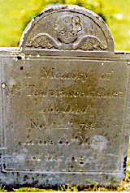
In Memory of
Mrs Temprance Hallet
who Died
Nov'r 22nd 1788
in the 60th Year
of her Age
 | William Hallet |  | 1798 - September 20 |  | 33

Jean Hallet 1799
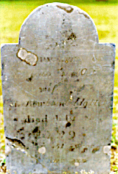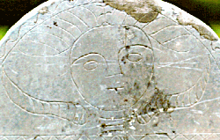
In memory of
Mrs Jean Hallet
wife of
Mr Rowland Hallet
died July 26
1799
in ye 31 year
of her age

Seth Hallet 1799
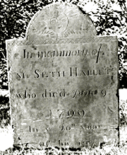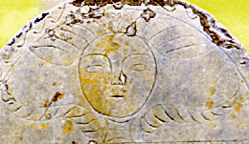
In memory of
Mr SETH HALLET
who died June 9
1799
in ye 26th year
of his age
Jonathan Hallett |  |  |  |  |  | 1802 - February 20 |  |  |  |  |  |  |  | 81
Edmund Hallet |  |  | 1804 - May 20 |  |  |  |  |  | 27
Hannah Hallet |  |  | 1805 - December 15 |  |  |  |  |  | 29
 | Lois Hallet  (wife of John) |  |  |  |  |  | 1805 - August 7 |  |  |  | 48
Charles Hallet |  |  | 1806 - January 30 |  |  |  |  |  | 23
Clement Hallet  (son of Joseph & Polly) |  |  |  |  | 1806 - September 16 |  |  |  |  | 2
 | John R Hallet  (son of Henry & Lucy) |  |  |  |  |  | 1808 - September 3 |  |  |  | 3 mos

Lucy Hallett 1808
In memory of
Mrs Lucy Hallett wife of
Mr Henry Hallett
she died June 6th 1808
in the 28th year of her age
Look on my friends and view this place
Where my poor body lies
But Jesus dwells beneath the grave
Yet lives above the skies

Joseph Hallet 1809
To the memory of
JOSEPH HALLET
Senior Deacon of the East Church, Barnstable
who departed this life
March 29th 1809
AEt 73 years, 6 months & 6 days
Though dead he yet speaketh
Mark the perfect man, and
behold the upright, for the end
of that man is peace
The format of the inscription is approximate. This was the largest gravestone in the cemetery in 1977. The stone was gone by April 1986.

Rowland Hallett 1816
In memory of
Mr Rowland Hallett
He died Aug'st 10th AD 1816
in the 74th year
of his age
My friends behold what Death has done
It's slain the aged and the young
Prepare to live, prepare to die
Prepare for long eternity

Barnstable - Hyannis
Universalist Church Cemetery
up to 1849

 |  | Eliza A Hallett  (dau of Allen & Relief) |  |  |  |  |  | 1840 - February 25 |  |  |  |  |  |  | 5
 | Cordelia Hallett  (wife of Charles G) |  |  |  |  |  | 1842 - November 6 |  |  |  |  | 23
Olive Hallett  (wife of Leander) |  |  |  | 1845 - July 3 |  |  |  |  |  | 37
 | Clarence F Hallett  (son of Freeman & Lucy B) |  |  |  |  |  | 1846 - September 10 |  |  |  |  | 14 mos
Lovica Hallett  (wife of Hartson) |  |  |  | 1849 - November 26 |  |  |  |  |  | 49

Barnstable - Osterville Hillside Cemetery

Daniel Hallett |  | 1800 - January 11 |  | ?

Samuel Hallett 1802
In memory of
Mr Samuel Hallett son of
Mr Samuel & Mrs Sarah Hallett
died April 17th 1802
in his 20th year
His pleasing hopes are gone
Death called him to an early tomb
But this is right since God is just
Who bade him mingle with the dust
infant Hallett  (dau of Benjamin & Abigail) |  |  |  | 1810 - May 24  (1810 - March 12) |  |  |  |  |  | 4 days
Samuel Hallett |  |  | 1813 - October 5 |  |  | 57
Sarah Hallett  (widow of Samuel) |  |  | 1814 - January 29 |  |  | 55
Theadore Hallett |  |  | 1817 - June 28 |  |  | 29

Azubah Hallet 1805
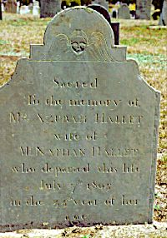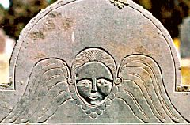
Sacred
to the memory of
Mrs AZUBAH HALLET
wife of
Mr NATHAN HALLET
who departed this life
July 7th 1805
in the 35th year of her
age

Kezier Hallet 1806
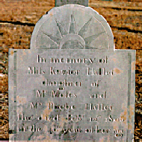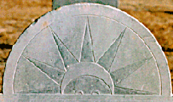
In memory of
Miss Kezier Hallet
daughter of
Mr Moses and
Mrs Phebe Hallet
She died Febr 12th 1806
in the 40th year of her age

Barnabas Hallet 1793
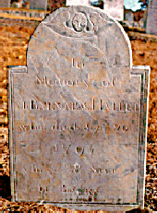
In
Memory of
Mr BARNABAS HALLET
who died Sep'tr 20
1793
In ye 38 Year
of his age
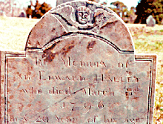
In Memory of
Mr Edward Hallet
who died March 8th
1796
In ye 49 Year of his age

Zubah Hallet 1801
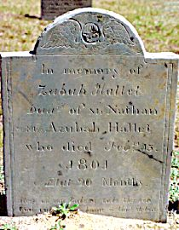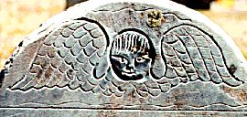
In Memory of
Zubah Hallet
Dau'tr of Mr Nathan
& Mrs Azubah Hallet
who died Feb'ry 13
1801
Etat 20 months

Stephen Hallet 1802
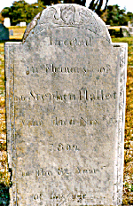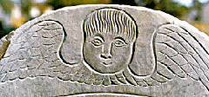
Erected
in Memory of
Mr Stephen Hallet
who died Nov'r 15
1802
in the 82 Year
of his age

Joseph T Hallet 1799
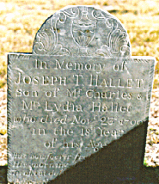
In Memory of
JOSEPH T. HALLET
Son of Mr Charles &
Mrs Lydia Hallet
who died Nov'r 23d 1799
in the 18th Year
of his Age

Warren Hallet 1811
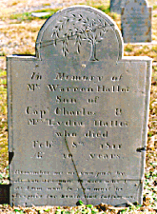
In Memory of
Mr Warren Hallet
Son of
Capt. Charles &
Mrs. Lydia Hallet
who died
Febr'y 8th 1811
AE. 20 years
Remember me as you pass by
As you are now, so once was I
As I am now so you must be
Prepare for Death, and follow me.

Charles Hallet 1821
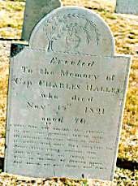
Erected
To the Memory of
Capt. CHARLES HALLET
who died
Nov'r 15th 1821
aged 70
When God our earthly bliss removes,
He has some gracious end in view
He always chastens those he loves
Yet makes them more than vanq'rors too
Pause every rising murmor then
And let me dry my falling tears
Tears in the hope of Heaven again
And banish all my doubts and fears.

Elisabeth Hallett 1821
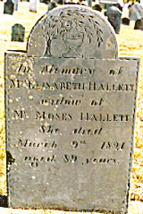
Erected
In Memory of
Mrs ELISABETH HALLETT
widow of
Mr MOSES HALLETT
She died
March 9th 1821
aged 89 years.

Joshua Hallet 1821
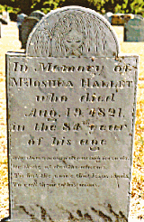
In Memory of
Mr JOSHUA HALLET
who died
Aug. 19, 1821
in the 84th year
of his age
Why do we mourn departing friends
Or shake at deaths alarms
Tis but the voice that Jesus sends
To call them to his arms.

Hope Hallet 1825
Polly Hallet 1825
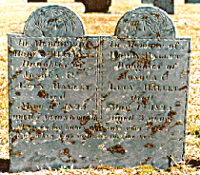
In Memory of
HOPE HALLET
Daughter of
JOSHUA &
LUCY HALLET
died
May 1st 1825
aged 7 years 6 months
In Memory of
POLLY HALLET
Daughter of
JOSHUA &
LUCY HALLET
died
May 1st 1825
aged 3 years
Weep on my babes and take your rest
For when God calls, tis for the best.

Moses Hallet 1809
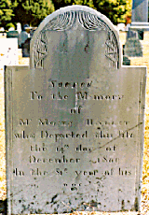
Sacred
To the Memory
of
Mr MOSES HALLET
who Departed this Life
the 14th day of
December 1809
In the 81st year of his
age.

